RFID Smart Cashier with Recommendation System

*Note: Sub-titles are not captured in Xplore and should not be used

In-on Wiratsin  
*Department of Computer Engineering Faculty of Engineering* *Mahidol University*Nakhon Pathom, Thailand  
inon.wia@student.mahidol.ac.th

line 1: 5th*)*line 4: C Country  
line 5: email address or ORCID

line 1: 6th Given Name Surname  
line 2: *dept. name of organization   
(of Affiliation)*  
line 3: *name of organization   
(of Affiliation)*line 4: City, Country  
line 5: email address or ORCID

*Abstract*—The study used Radio Frequency Identification (RFID) to get data of each item that will be purchased. Based on data analytic technique, this research focus on the use of association rules. The collected data from RFID then compared with the rules, and the system will be able to recommend the items that customers might interest respected to the association rules. All transactions will be kept in record and be able to utilize in terms of increasing more samples in dataset to improve the association rules, and in terms of business intelligences, such as warehouse management, reducing cost and time, faster process, better resource allocation.

Keywords—Radio Frequency Identification, Association Rule, Business Intelligence

# Introduction

Nowadays, supermarket is place that sell foods, beverage, and some other various kind of utilities. Somewhere many people went to regularly to buy something for their daily needs. People enjoy shopping, but surely no one enjoys waiting in the endless line to check out at the cashier. Some stores has less number of staff resulting resource management at the cashier a crucial problem. Some might get tired of waiting end up returning the products. This inefficiency not only lead to the loss in profit, but also the opportunity to promote other products to the customers.

The Radio Frequency Identification (RFID) will be used for the project. RFID are affordable which it has also been used in many countries and many fields. Some fields that uses RFID include dairy farm, agricultures, clothing, car parking, and security management.

The benefits of higher efficiency cashier are that they are more convenient for the customers. Cheaper cost for the company compared to human’s workforce hours. Data collected from cashier can also increase efficiency of stock management, monitoring status of each item which allow to analyze the demand of each supply. It can also be used to offer related product that they might be interested in to the customers. Monitoring customer’s behavior will also be able to help improve customer’s experience, improve loyalty program for customer to increase profit.

# Literature Review

## Auto-Checkout System for Retails using Radio Frequency Identification (RFID) Technology

Busu et al. [1] propose system was design to make cashier faster and more efficiency, reducing the time in queue for groceries check out. The system flow for the Auto-Checkout system are put groceries in trolley, check out at the cashier where there is line indicating where the trolley need to be. After detecting the groceries the system will the list out the groceries with the price and summation of total amount, the receipt will then be print.

The groceries are embedded with Ultra High Frequency (UHF) RFID tag. The reader was set at the cashier, a line was drawn to indicate the area where trolley should be for the reader to detect the items. The project RFID system was integrated with Graphical User Interface (GUI) developed in the host PC. Acting like an application that communicate between computer and the RFID system.

Database was also created to store detail of the groceries. The project used Microsoft Access (MA) for database. The database allow information to be edited, add new items, or delete items. The groceries list stored in database each has detail as follows : ID, Product Name, Category and Price. Since every product has different ID the system recognized each groceries by tag ID read. Displaying the detail of groceries into a list for check out.

## RFID Technology in Business Systems and Supply Chain Management

Yuksel et al. [2] proposed that RFID became one of the innovation system that will be able to provide easy and quick data entry, storage and transmission. It can be used where large amount of data need to be manage with real time data such as stores, hospital, and logistic services. Being able retailers to provide right product at the right place at the right time, which will help maximize sales and profit. It improves data management capabilities and resolves problems cause by lack of information, improve efficiency, cutting costs, and increasing sales by reducing out-of-stock.

Main feature of RFID are its ability to identify, locate, track, and monitor without the need to be clear of sight between object’s tag and reader. Industry adopt to using RFID will be able to increase volume of usage, lower cost, develop effective business models, improve collaboration and supply chain management.

Example company that uses RFID is one of well-known American largest public organization, Wal-Mart. They saw it as one of a solution to reduce the cost of handling goods, also giving the chance to create database with data of customers’ need. Having data that are easily access and updated dynamically in real-time, with stocks are controlled and tracked storehouse and selling control can be done for efficient stock management. With the RFID. lost time and manpower can be decreased, with its unique identification code and data protection from cryptographic algorithms can also prevent unauthorized access for security reason.

## Data Mining Association Rules Applied to Supermarket Transactional Data Modeling: a case study in Brazil

Data collected can be used for decision making support on operational and strategic levels. Transferring data into knowledge. Paes et al. [3] propose system with main application using the association rule of Market Basket Analysis (MBA), to search for consumer behavior patterns. Which will be able to help organization on managing project layout, e-commerce, and other product marketing strategies.

The proposed system experiment was performed in a local supermarket in Brazil. Result from using existing database, noise free and organized proved very important to the analysis. Database with those characteristic is possible to generate quality results that will be able to represent customers’ behavior pattern. Problem that they encountered in decision making are usually not made by the same person, decision maker does not know how to use it in the decision making process. The advantage is that the implementation is easy, with the association rule mining it provide accurate summary on how items are related to each other’s.

# methodology

## System Design

The smart cashier cabinet is embed with an Arduino UNO which is connected with RFID module PN532 and touch switch (see Figure 1). RFID PN532 module will read data from RFID tag, in this paper we introduce 15 sample tags (see Figure 2) and 1 sample credit card. Touch switch will be pressed when the item scanning is done. It will require the valid payment by scanning the specific card, if scanning fail over 5 times, it will reject the current transaction and ready for the new transaction. The flowcharts of the system are shown as in Figure 3 and 4.

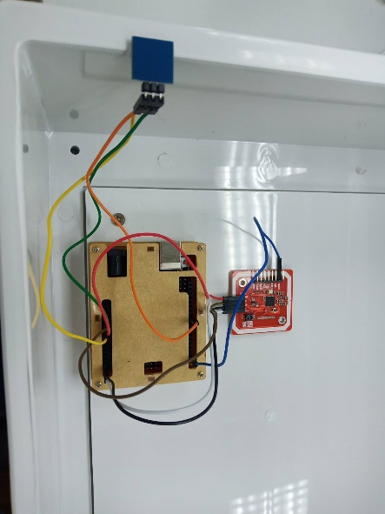

**Figure 1:** Hardware components

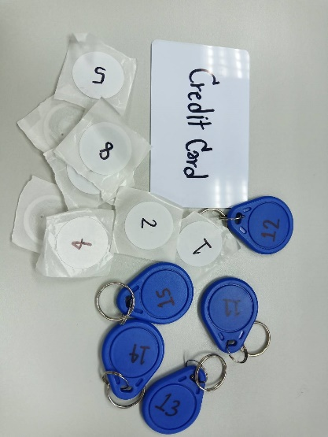

**Figure 2:** Samples of RFID tags and credit card

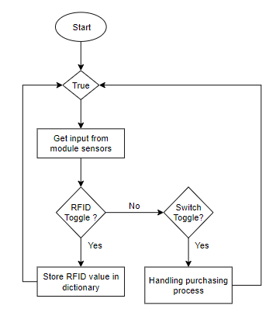

**Figure 3:** Smart cashier flowchart

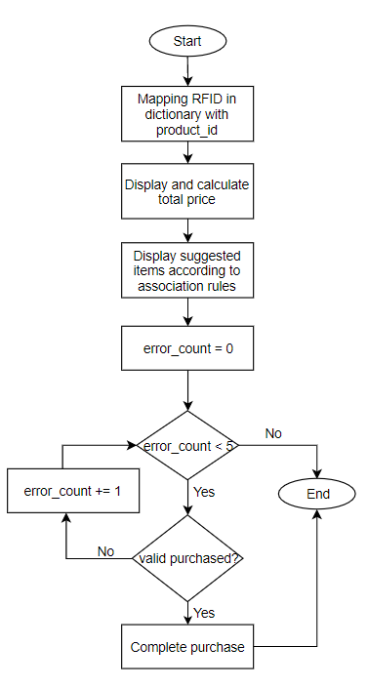

**Figure 4:** Handling purchasing flowchart

In terms of data analytic, we used dataset “Instacart Market Basket Analysis” from www.kaggle.com [4] to find association rule in this scenario. All 45,150 rules were stored in rules.csv, each has its own id, name, aisle number, and department etc. We upload this dataset into Colab and implement Python to find association rule, sorting from the highest Lift value. Then, we map RFID tag with item code, in this scenario we introduce 15 items (see Figure 5).

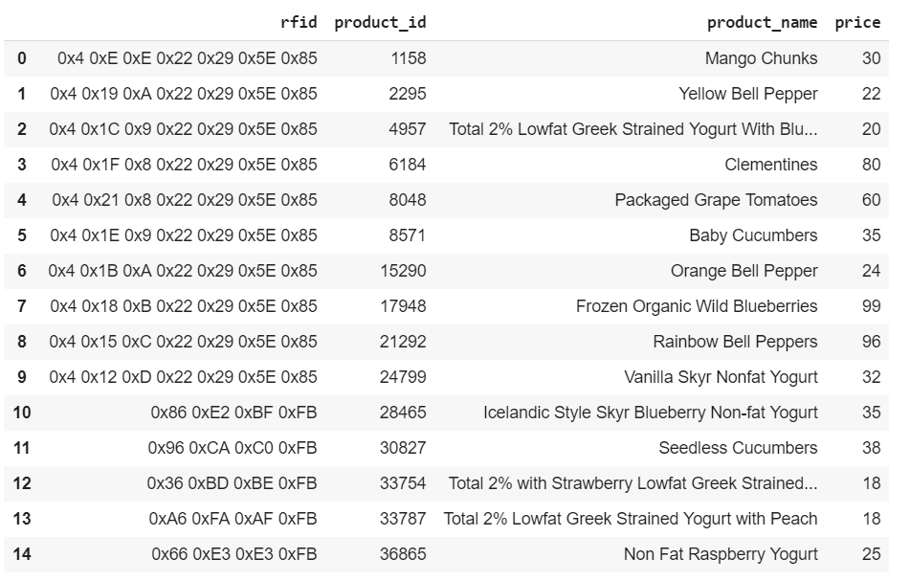

**Figure 5:** Result from Mapping_RFIDitems_GG.ipynb

## System Components

* Hardware components consist of Physical cabinet, RFID module, RFID tags, Arduino UNO, touch switch, and LCD display.
* Software components consist of Arduino IDE for controlling Arduino UNO, RFID module and touch switch. Colab for association rule data analysis. Python 3.6.3 for recommendation system and report generating.

# experimental result

## The Use of Association Rules

After run the association rule in Colab, we obtained the rules for our recommendation system (see Figure 6). Each rule present the pair of items that customer usually brought together. Noted these data will be used to map with 15 items in the experiment. 15 values of RFID tags stored in rfid_nfc_uid.csv. Those tags were map with 15 items in products.csv. To clarify, important data of 15 items that will be used in this study consist of RFID value, product ID, product name, and product price, these data stored in store.csv.

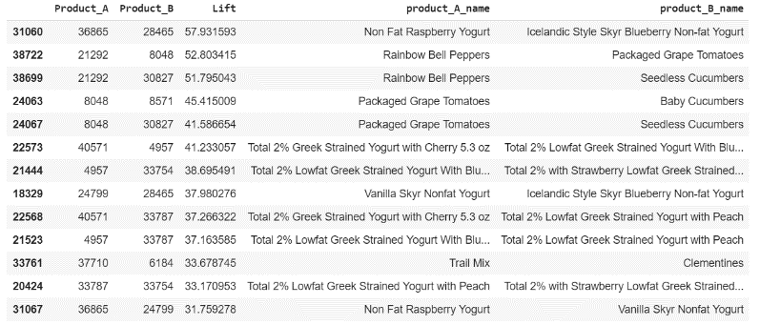

**Figure 6:** Result from Generate_Rules_GG.ipynb

## Hardware Components

We connect RFID module PN532 and touch switch with Arduino UNO, and use Arduino IDE to control and get input data from RFID tags (see Figure 7). PN532 will read the RFID tags and show value in serial monitor, while pressing touch switch will toggle and show the output “Exit” (see Figure 8) .

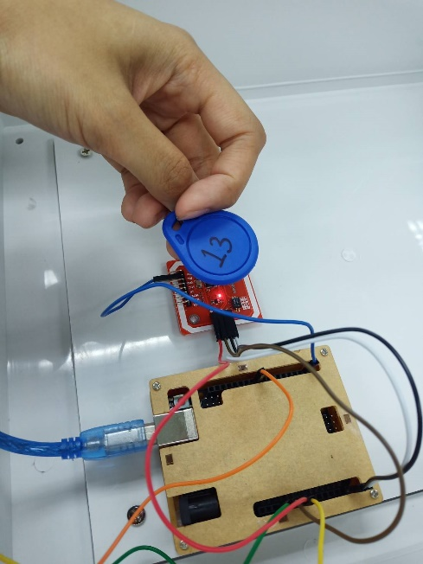

**Figure 7:** Scanning RFID tags

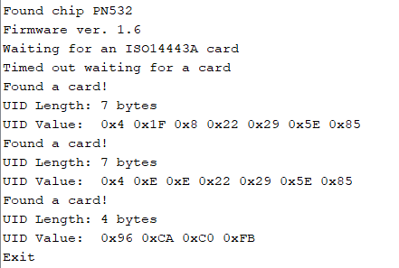

**Figure 8:** Serial monitor from iso14443a_uid_original

## Integrating Python with Arduino IDE

This research applied Python 3.6.3 to process input data from Arduino components. Firstly, it will capture the output from PN532 in serial monitor and handle the error. Then, when switch was toggled it will summarize the purchasing, and show recommendation items to customers (see Figure 9). After, payment was verified then the receipt will be generated and stored in order_profile.csv (See Figure 10 and 11).

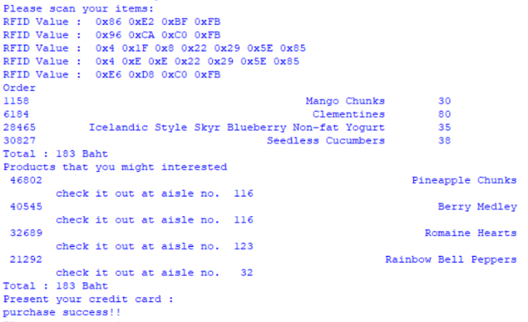

**Figure 9:** Result from CashierV1.py

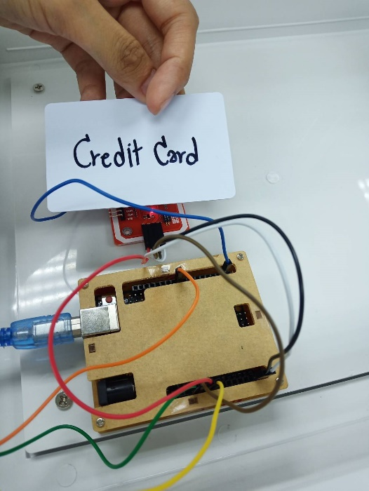

**Figure 10:** Scanning sample credit card

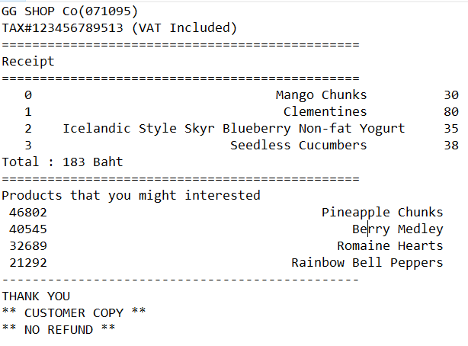

**Figure 11:** Receipt example

# conclusion

## Discussion

In this research, we implement the use of Arduino UNO with RFID PN532 module and touch switch to get data and integrate Arduino IDE with Python 3.6.3. For data analysis part requires the use of data mining techniques which focus on association rule analysis, the system will recommend the items that response to the rules. System will keep the record in csv file, which ca be using to enhance the rules in further.

## Future work

Cashier could be improved with real payment verification. Installing multiple tags reader to increase the efficiency of reading items. The collected data can also be used for further analysis in terms of business intelligences, such as stocking management, re-ordering the products based on customers’ demand automatically, resource allocation, and faster business process to increase profits.

##### References

1. M. F. M. Busu, I. Ismail, M.F. Saaid and S. M. Norzeli, “Auto-Checkout System for Retails using Radio Frequency Identification (RFID) Technology”, 2011 IEEE Control and System Graduate Research Colloquium, [Online]. Available: DOI:10.1109/ICSGRC.2011.5991855.
2. M. E. Yuksel and A. S. Yuksel, “RFID Technology in Business Systems and Supply Chain Management”, Journal of Economic and Social Studies, vol. 1, pp. 53-71, Jan. 2011. DOI:10.14706/JECOSS11115.

[3] V. Paes, P. P. Balestrassi and A. P. Paiva, “Data Mining Association Rules Applied to Supermarket Transactional Data Modeling: a case study in Brazil”, International Joint Conference - ICIEOM-ADINGOR-IISE-AIM-ASEM (IJC2017, Valencia, Spain, July 6-7, 2017.

[4] “Instacart Market Basket Analysis” Dataset. Retrieved from https://www.kaggle.com/psparks/instacart-market-basket-analysis